SUMMING OF SERIS

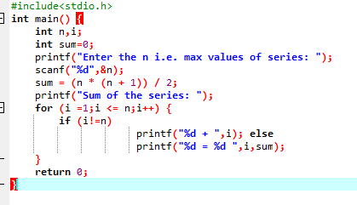

OUTPUT

